

**BAYPINES BEACON**

*Serving United Methodist Women in the Baypines District*

MISSION TEAM 2019

President

Gerry Stiffler

[Geraldinestiffler@msn.com](mailto:Geraldinestiffler@msn.com)

251 942-7792

Vice President

Beth Henson

[bah9103@aol.com](mailto:bah9103@aol.com)

Secretary

Carolyn Anderson

halcar114@gmail.com

Treasurer

Susan Morrison

[smorrisonmg@gmail.com](mailto:smorrisonmg@gmail.com)

Program Resources

Sharon Anderson

[jw.anderson@frontier.net](mailto:jw.anderson@frontier.net)

Communications

Dell Walston

[dellhwals@gmail.com](mailto:dellhwals@gmail.com)

Spiritual Growth

Judy Hust

[bjhust@earthlink.com](mailto:bjhust@earthlink.com)

Social Action

Michelle Nelson

[corbettandmiasmimi@gmail.com](mailto:corbettandmiasmimi@gmail.com)

Membership, Nurture & Outreach

Kathy Marler

[kathleen6307374@gmail.com](mailto:kathleen6307374@gmail.com)

Education & Interpretation

Deborah Johnson

[mailady565@yahoo.com](mailto:mailady565@yahoo.com)

Program Resources

Sharon Anderson

Jw.anderson@frontiernet.net

*September 2019*

Baypines Mission Team

*President*

*Gerry Stiffler*

*Vice President*

*Beth Henson*

*Secretary*

*Carolyn Anderson*

*Treasurer*

*Lyn Stuart*

*Spiritual Growth*

*Judy Hust*

*Education/Interpretation*

*Deborah Johnson*

*Communications*

*Dell Walston*

*Membership, Nurture*

*& Outreach*

*Patricia McKee*

*Program Resources*

*Bridget Glidewell*

Gerry Stiffler, President

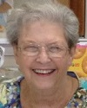

**In 2019 our Alabama-West Florida United Methodist Women**

**Theme and scripture focus:**

***“Love in Action”***

***(1 John 3:18)***

***Greetings Ladies,***

***For this newsletter, most of it consists of remaining meetings for 2019. We hope you will consider attending some (or all) of these events. We have a great group of ladies and I personally look forward to these meetings so that we can visit with both “old friends” and “new friends”. Will I see YOU?***

***Gerry***

***Dates for the Fall***

**September 21**, the second Mission u study in our Baypines District will be at Morgan’s Chapel in Bon Secour. The ladies have invited all of us to join them at 9:30 for the study. Charlotte Ainsworth of Foley UMW will lead the study of *United Methodist Women in Mission.*

**October 5**, our District Spiritual Day Apart will be in Frisco City UMC beginning with a brunch at 9:30 a.m. The speaker for the day is Rev. Tammy McMillian, minister of Stapleton, UMC.

**October 11-12,** Conference Spiritual Enrichment Day will be at our church Camp, Blue Lake. Registration is at 3:00 pm on the 11th. The speaker for the weekend will be Rev. Reba Wiley, presently serving Pine Hill UMC. She has served 39 years in the Alabama West Florida Conference and was the District Superintendent of the Demopolis District for 7 years. We will be dismissed after a Communion Service in the chapel on Sunday morning. Our District has scholarships for this weekend. See Susan Morrison for information.

**October 21**, our committee for Racial Reconciliation is hard at work making plans for our trip to Montgomery, by bus, to visit the Peace and Justice Museum. There will be $20.00-dollar charge for the bus fare and the museum ticket. The bus will leave the Robertsdale UMC parking lot at 6:00am proceed to pick up in Bay Minette at 6:45am. Other stops along Hwy 65 may be arranged to accommodate passengers. Please encourage one or two from your unit and your pastor to make this trip with us.

**November is UMW Month**, please encourage your Unit to have posters and take part in the service one of the Sundays in the month. Celebrate and educate others about the great work we have done and continue to do in the global missions of the world.

**April 17-19, 2020**Southeast United Methodist women will convene in Mobile with our Jurisdictional Meeting. This is the first time this meeting has been in the state of Alabama. Betty Helms, form Dothan District is the Jurisdictional President and has honored us with holding the meeting in Mobile. Make plans to be a part of this meeting. We can all drive there for one day, even if we don’t choose to be a full attendee. Please don’t miss this wonderful experience.

Our Conference Spiritual Enrichment Retreat

“Love in Action” 1 John 3:18 is the theme of our Spiritual Enrichment Retreat event at Blue Lake, our Conference Camp, and it is just around the corner. October 11, 12, & 13 will be a great time for fellowship, relaxing and spiritual renewal.

The Rev. Reba Wiley will be our featured speaker. She has been in ministry for years and has served as the District Superintendent of the Demopolis District. The music will be led by Sarah Fell.

We also have three great focus groups: Armchair Yoga: taught by Susan Hill, a yoga teacher who won’t make us get on the floor; Jay Locker will be teaching crocheting for beginners and the more advanced folk will be making crosses for wall hangings. She has a friend who will be crocheting plastic bags into crosses. Finally, Linda Carden will be teaching us how to make beautiful crosses on plaques that are great for hanging or displaying on easels. Make sure that you choose the two focus groups that you want when you register.

If you need help filling out the forms or have questions, please call Jean Creswell, our Conference treasurer at 334-385-2521. Costs vary according to how many nights you will spend and the meals you will eat. Everyone must pay the $15 registration fee even if you are not spending the night or eating meals. Register on time to avoid paying the Late Fee of $10.00.

Please share the forms with anyone who would like to attend. You won’t regret your time spent with fellow Christian ladies a in lakeside retreat. Come one day or spend the whole weekend.



|  |  |  |  |  |  |  |  |  |  |  |  |  |  |  |  |  |  |
| --- | --- | --- | --- | --- | --- | --- | --- | --- | --- | --- | --- | --- | --- | --- | --- | --- | --- |
| ALABAMA WEST FLORIDA CONFERENCE | | | | | | | | | | | | | | | | | |
| UNITED METHODIST WOMEN HEALTH FORM | | | | | | | | | | | | | | | | | |
| For the Calendar Year | | | | | | | | 2019 | | | | | | | | | |
| Authorization for Emergency Medical Treatment Form | | | | | | | | | | | | | | | | | |
|  | | |  |  | |  | | |  | | | | |  | |  |  | | |
|  | | | | |  | | |  | | | | |  | | | | |
| Name | | | | |  | | | DOB | | | | |  | | | | |
|  | | |  |  | |  | | |  | | | | |  | |  |  | | |
|  |  |  | | | | | |  | | |  | | | | | | |
| Home Phone |  | Work # | | | | | |  | | | Cell # | | | | | | |
|  | | |  |  | |  | | |  | | | | |  | |  |  | | |
|  | |  | | |  | | | | | |  | |  | | | | |
| Physician's Name | |  | | | Phone # | | | | | |  | |  | | | | |
|  | | |  |  | |  | | |  | | | | |  | |  |  | | |
|  | | | | |  | | | | | |  | | | | | | |
| Health Insurance Company | | | | | Policy # | | | | | | Group # | | | | | | |
|  | | |  |  | |  | | |  | | | | |  | |  |  | | |
| Allergies to medications: | |  | | | | | | | | | | | | | | | |
|  | | |  |  | |  | | |  | | | | |  | |  |  | | |
| Other Allergies (food, animals) | |  | | | | | | | | | | | | | | | |
|  | | |  |  | |  | | |  | | | | |  | |  |  | | |
| Conditions that treating personnel might need to be aware of: | | | | | | | | | | | | | | | | | |
|  | | | | | | | | | | | | | | | | | |
|  | | |  |  | |  | | |  | | | | |  | |  |  | | |
| In the event emergency medical aid/treatment is required due to illness or injury during my stay at a UMW event, I authorize ALWF UMW to: | | | | | | | | | | | | | | | | | |
|  | |  | | | | | |  | | | | |  | | | | |
| Name | | Relation | | | | | | Phone # | | | | | Alt. Phone # | | | | |
|  | |  | | | | | |  | | | | |  | | | | |
| Name | | Relation | | | | | | Phone # | | | | | Alt. Phone # | | | | |
|  | | |  |  | |  | | |  | | | | |  | |  |  | | |
| ***PLEASE CHECK ONE OF THE BELOW PLANS*** | | | | | | | |  | | |  | |  | | | | |
|  | | | **Consent Plan** |  | | |  | | |  | |  | | |  | | | |
|  | | | **In the event emergency medical aid/treatment is required due to illness or injury during my stay at a UMW event, I authorize ALWF UMW to:** | | | | | | | | | | | | | | |
|  | | | 1. Secure and retain medical treatment and transportation if needed. | | | | | | | | | | | | | | |
|  | | | 2. Release my health information to the authorized individual or agency involved in the medical emergency treatment. | | | | | | | | | | | | | | |
|  | | | 3. I hold harmless the AL-WFL Conference United Methodist Women, the ALWF Conference, The United Methodist Church and/or the owners of the facility for which the event is taking place for any act or failure to act during a medical emergency. | | | | | | | | | | | | | | |
|  | | |  |  | |  | | |  | | | | |  | |  |  | | |
|  | | | **Non-Consent Plan** |  | | |  | | |  | |  | | |  | | | |
|  | | | **I DO NOT give my consent for emergency medical treatment/aid in the cases of illness or injury. In the event emergency treatment/aid is required, I wish the following procedures to take place:** | | | | | | | | | | | | | | |
|  | | | I hold harmless the AL-WFL Conference United Methodist Women, the ALWF Conference, The United Methodist Church and/or the owners of the facility for which the event is taking place for any act or failure to act during a medical emergency. | | | | | | | | | | | | | | |
|  | | |  | | | | | | | | | | | | | | |
|  | | |  |  | |  | | |  | | | | |  | |  |  | | |
|  | | | | |  | | |  | | | | | | | | | |
| Your Consent Signature | | | | |  | | | Date | | | | | | | | | |
|  | | |  |  | |  | | |  | | | | |  | |  |  | | |
|  | | | | |  | | |  | | | | | | | | | |
| Witness Signature | | | | |  | | | Date | | | | | | | | | |

* * * * * * *

Legacy Cookbook

Ladies, the Southeast Jurisdiction Core Planning Group is putting together a Legacy Cookbook and we are

in need of about 25 recipes from our conference to submit as our contribution to this cookbook.  Each conference is being asked to send it at least 25 recipes to me and I will have them compiled and put into a really nice cookbook.  Also, each conference in our jurisdiction will have a brief history printed in the cookbook. so not only will you get some really GREAT recipes but also have a brief history which will really make it a Legacy Cookbook. So, I am issuing an appeal to my conference to help me with this task.  The deadline is December 15, 2019.

You can order your copy of the cookbook when you register on line at a cost of $15.  If you wait until the Jurisdiction Meeting in April the cost will be $20.

Thanks for any and all help with this project.

Betty Helms

<[betty194159@outlook.com](mailto:betty194159@outlook.com)>

|  |  |  |  |
| --- | --- | --- | --- |
| Local Unit Reporting Dates | |  |  |
|  |  |  |  |
| DUE DATE | REPORT | REPORT TO | DONE BY |
| All year-Last Amount Due November 30 | Treasurer's Remittance Form | Susan Morrison | Unit Treasurer |
| January 10 | Names of Deceased Members | Gerry Stiffler, District President &  Kathie Marler, MN&O | Unit President & Unit Secretary |
| November 30 | All Local Funds for Five Star Unit | Susan Morrison | Unit Treasurer |
| November 30 | Local New Unit Report | Gerry Stiffler & Carolyn Anderson | Unit Secretary |
| November 30 | Local Unit Officer List for Next Year | Carolyn Anderson | Unit Secretary |
| November 30 | Mission Today Unit | Deborah Johnson | Unit E&I & Unit Secretary |
| November 30 | Charter for Racial Justice | Gerry Stiffler & Michelle Nelson | Unit President & Social Action |
| November 30 | Consolidated President's Report | Gerry Stiffler | Unit President |
|  |  |  |  |
|  |  |  |  |
| Gerry Stiffler, President 117 Natchez Trace Foley, AL 36535 251-942-7792 | | | |
| Susan Morrison, Treasurer 337 Monteith Oaks Dr Foley, AL 36535 251-680-0022 | | | |
| Carolyn Anderson, Secretary 509 Juniper Place Dr Foley, AL 36535 931-260-4852 | | | |
| Michelle Nelson, Social Action 18644 Outlook Dr Loxley, AL 36551 251-709-9433 | | | |
| Kathie Marler, MN&O 21624 Houston Crossing Rd Andalusia, AL 36431 850-630-7374 | | | |
| Deborah Johnson, E&I 318 Manchester Lane Foley, AL 36535 251-943-7670 | | | |
|  |  |  |  |
| E&I = Education and Interpretation | |  |  |
| MN&O = Membership Nurture and Outreach | | |  |
|  |  |  |  |

Judy Hust

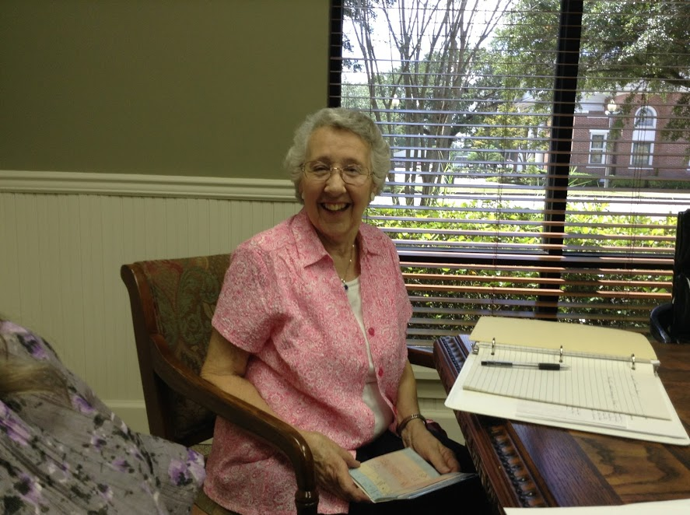

Baypines District Coordinator for Spiritual Growth

United Methodist Women have an opportunity to reflect on the gospel of Christ and make an offering that helps sustain ministry around the country and the world. Because our purpose encourages us to “know God” and grow spiritually we have a mini-spiritual retreat each year. This year our district Day Apart will be in Frisco City United Methodist church on Saturday, October 5, 2019. Our speaker will be Rev. Tammy McMillan (see her bio below) who will inspire us to put our love into action for women, youth and children around the world. So please put this date on your calendar now. The meeting will begin at 10:00. The Frisco City ladies will serve brunch promptly at 10:00 so arrive a few minutes early, register, and bring a hearty appetite with you!

Please ask your unit to make a very special offering as it will go to our own Dumas Wesley Center in Mobile. Please encourage your unit to take time to experience God’s renewal and have your soul refreshed.

*Our United Methodist Women’s Purpose calls us to be a place where women can be whole in Jesus Christ. Are we this place? Let us study this year to be this place and the person that God wants us to be.*

About our speaker:

Tammy McMillan is the pastor of Stapleton UMC. She attended licensing school in 2018 and is currently enrolled in classes through the Course of Study. Tammy felt called to special services as a teen in a Baptist church camp. But it wasn’t until she moved from Oklahoma to Alabama and witnessed female pastors at the Spanish Fort UMC church and followed her husband to Holly Grove UMC that she learned she could actually be an active leader in church services.

Tammy attended Southwestern Oklahoma State University and the University of Central Oklahoma. She holds a BS in Vocational Home Economics Education, an Elementary teaching certificate and a MS in Educational Competencies. She has taught elementary school in Oklahoma City, and was a visiting professor at the University of Oklahoma. Tammy has worked in Oklahoma, Louisiana and Arkansas as a Fellow for the A+ school initiative. Through this organization she facilitated professional development that aided school faculties in thinking, planning and behaving more creatively.

Tammy’s husband, Robert, is the pastor of Morgan’s Chapel and works full time at Mobile Infirmary as a physician in training and support specialist. Robert and Tammy have one daughter, Ashlyn who travels the United States in a van with her boyfriend and their two cats, Kiwi and Cashew.

Tammy’s interests include Jazzercise, reading, gardening, playing the piano and sewing.

***Michelle Nelson***

***SOCIAL ACTION***

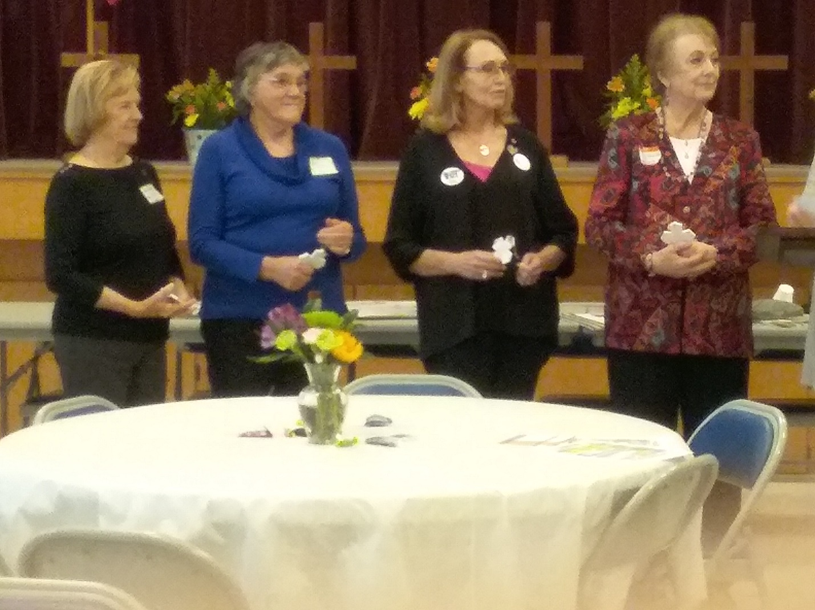

***United Methodist Women: We Are Love in Action!***

**PILGRIMAGE TO MONTGOMERY:**

**EQUAL JUSTICE INITIATIVE’S NATIONAL MEMORIAL FOR PEACE & JUSTICE and LEGACY MUSEUM**

**OCTOBER 21, 2019**

*Sponsored by : Baypines United Methodist Women, Baypines District United Methodist Church,*

*and United Methodist Board of Church & Society*

The museum and memorial are part of EJI’s work to advance truth and reconciliation around race in America and to more honestly confront the legacy of slavery, lynching, and racial segregation. (Source: EJI website)

A pilgrimage is a sacred journey. It is “a journey embarked upon with the intention of encountering God and experiencing transformation.”

([asacredjourney.net](http://asacredjourney.net)) It is a discipline that can aid us in spiritual formation toward the transformation of ourselves and our world.

**DEADLINE FOR REGISTRATION AND PAYMENT: Sept. 21, 2019**

**Date: October 21, 2019**

**Time: 6 AM - 7PM**

**Cost: $20.00 This includes the bus and entrance to the museum and the memorial. If you find that you’re unable to make the trip, please share your spot with a friend since we will be unable to make refunds. Thank you!**

**Mail check and attached registration form to: Foley United Methodist Church, 915 N. Pine Street, Foley, AL 36535 attention: Susan Morrison**

**Made out to: Baypines District UMW**

Bring a lunch/snacks, etc. to eat on bus. **We will not stop for lunch**. The bus is equipped with a rest room. Wear comfortable clothes and walking shoes.

**OPEN TO ANY AND ALL ON FIRST COME BASIS!**

Charter bus Details:

6:00am - leave Robertsdale United Methodist Church

6:45am - pick up additional pilgrims at Bay Minette United Methodist Church

(A reflection/note taking guide will be provided.)

***If you are NOT riding the bus, you may join us for this pilgrimage at River City Church, 301 Dexter Avenue, Montgomery. You will need to purchase your own tickets in advance at*** [***EJI.org***](http://EJI.org)***. Pick 10:30 or closest time available for timed museum entrance ticket. Entrance to Memorial is not timed.***

10:00am - arrive River City Church to join rest of the pilgrims for short focus discussion

10:30am - Tour Legacy Museum

12:00 Return to bus to eat bagged lunch and travel to Memorial

12:30pm - Tour National Museum for Peace & Justice

2:00pm - Board bus and return to River City Church for reflection and Holy Communion

3:15pm - Board bus for return to Baldwin County.

**Please consider joining us in expecting to see God at work in our hearts and minds, to hear God nudging us forward as we face harsh truths and realities, and to answer God’s call to unite us in love as we take action towards creating a more loving, caring, and inclusive community.**

For more information contact:

Susan Morrison

smorrisonmg@gmail.com

**United Methodist Women**

**We are LOVE IN ACTION.**

- - - - - - - - - - - - - - - - - - - - - - - - - - - - - - - - - - - - - - - - - - - - - - - - - - - - - -

REGISTRATION FOR PILGRIMAGE TO MONTGOMERY

OCTOBER 21, 2019

Please include $20.00 check made out to Baypines District UMW

and mail to: Foley United Methodist Church

915 N. Pine Street

Foley, Al 36535

Attn: Susan Morrison

Payment should be received on or before September 21, 2019.

Bus capacity is 56.

***If you find that you are unable to make the trip, please share your spot with a friend since we will be unable to make refunds. Thank you!***

NAME:__________________________________________________

ADDRESS:______________________________________________

CELL PHONE:_____________________Do you text? __Yes __No

EMAIL:_________________________________________________

___ Boarding bus at Robertsdale United Methodist Church

___ Boarding bus at Bay Minette United Methodist Church

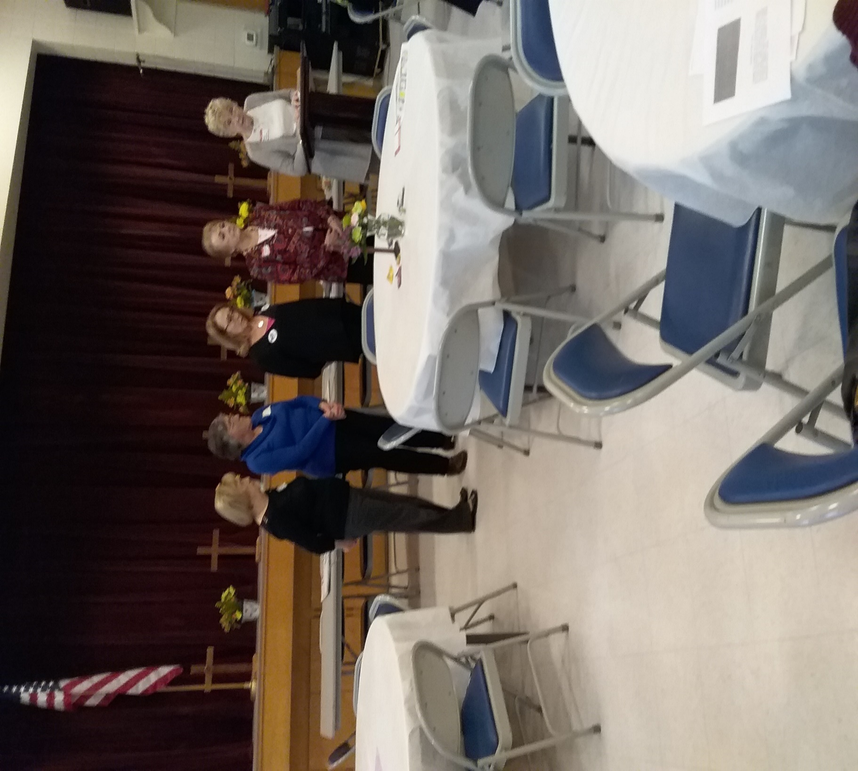***2019 Installation of Officers***

These ladies were installed during the January 19, 2019 Training and Annual Day meeting that was held in Bay Minette at the First UMC. Peggy Cunningham, the previous district president, installed the new officers; left to right: Dell Walston, Communications; Sharon Anderson, Program Resources; Michelle Nelson, Social Action and Kathy Marler, Membership N&O; Peggy Cunningham, installation officer.

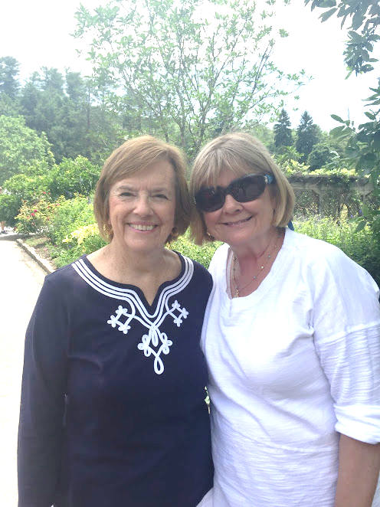

COMMUNICATIONS, Dell Walston

On behalf of the Frisco City United Methodist Women, I want to extend an invitation to all of you to attend the October 5 Baypines Spiritual Day Apart in Frisco City.

Our ladies are happy to host this special occasion and we are preparing a delicious brunch for you in the fellowship hall at 10:00 a.m. After the brunch we will go into the sanctuary for the program. (See Gerry and Judy’s articles for more details about the program.)

Your Mission Team has planned a wonderful program – you will not be disappointed! We look forward to enjoying this special day with all of you!

A couple of photos from the Bay Minette First UMC District Training Day January 19, 2019:

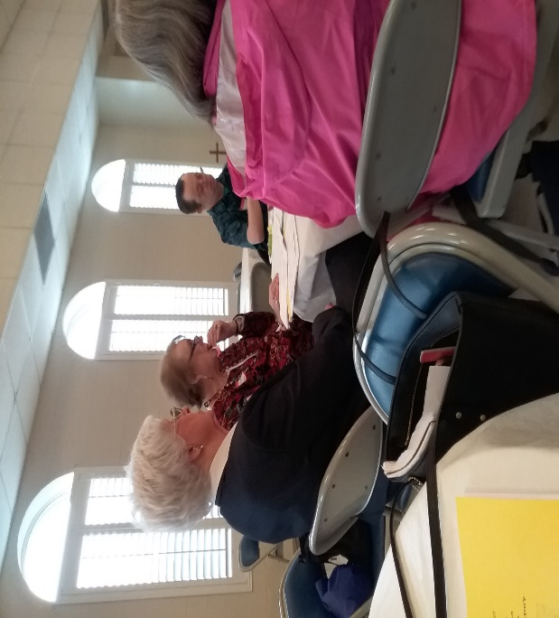

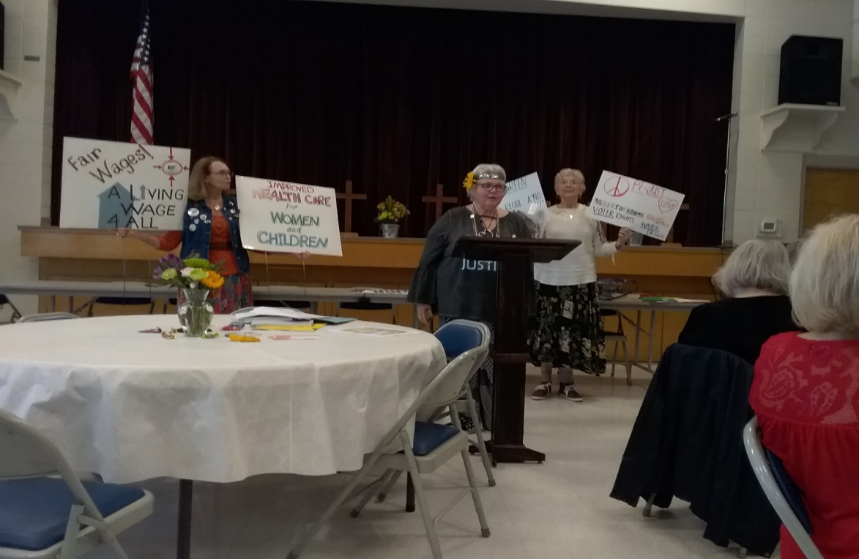

Holly Grove UMC, August 10, 2019

East Baypines Mission U – Speaker: Debbie Braswell, Dothan District President

A special “thank you” is extended to the Holly Grove UMC ladies who graciously welcomed us and provided lunch.

Photos provided below of the hostesses, some of the attendees and some of our district officers.

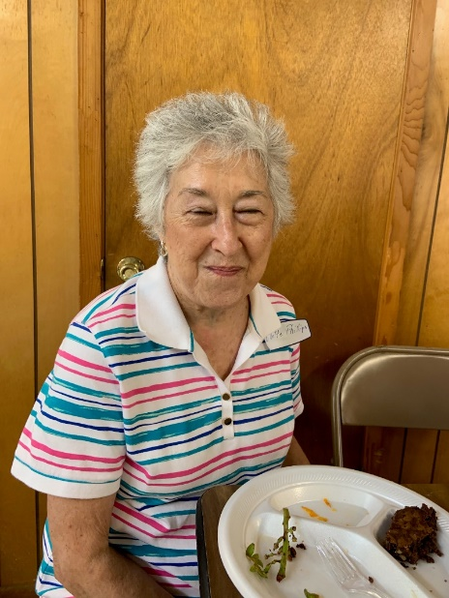 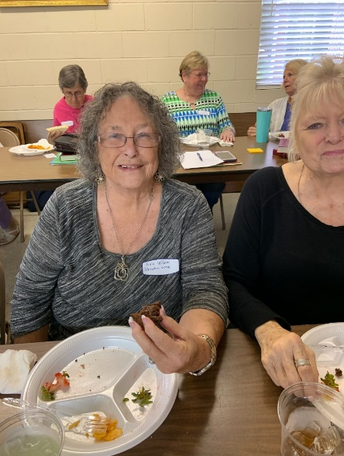 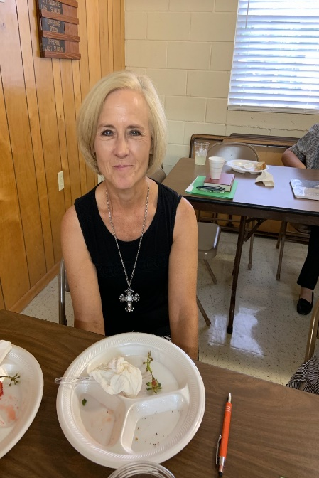

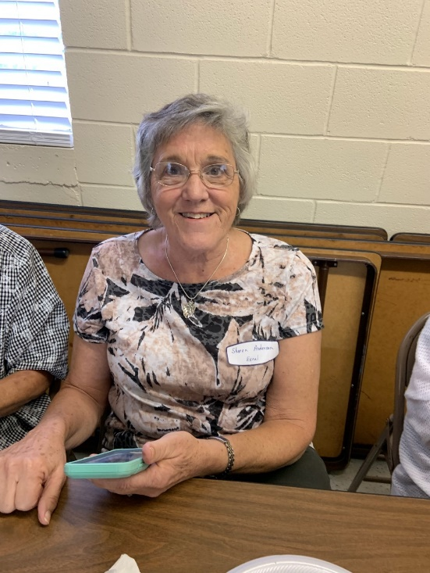 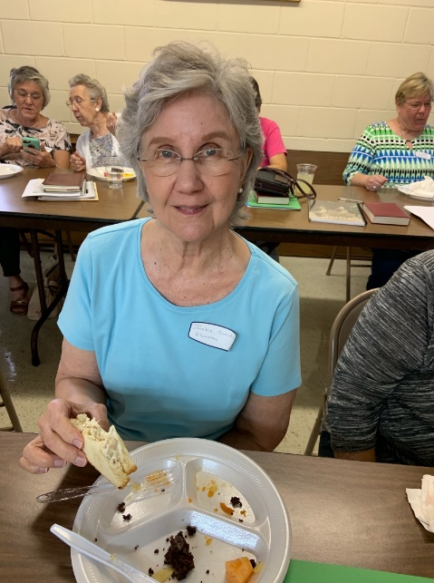 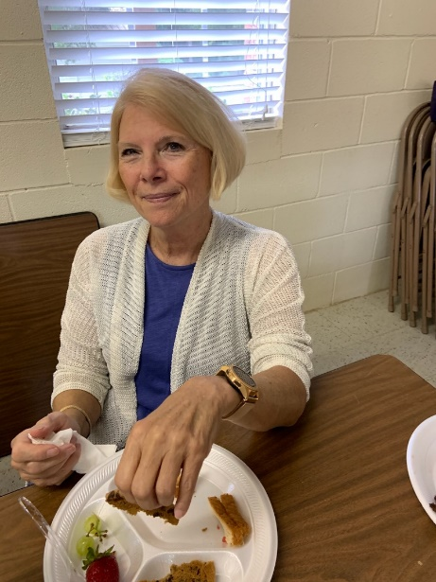 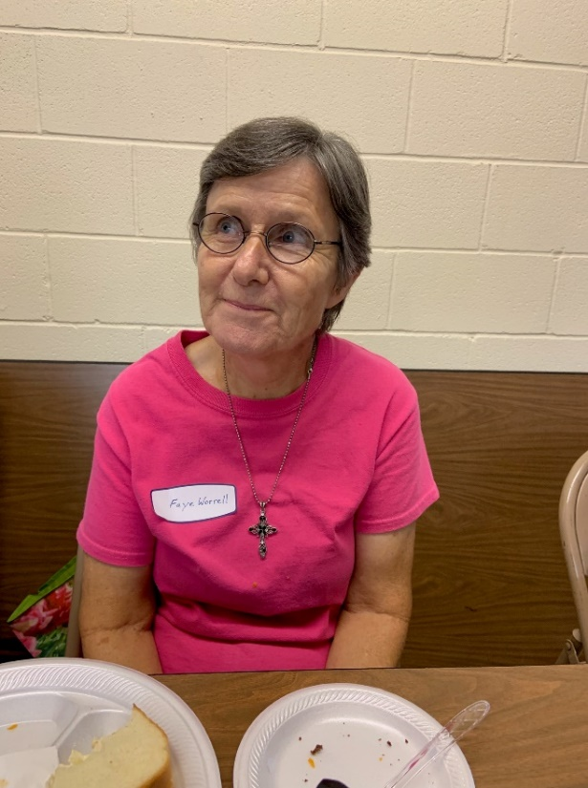

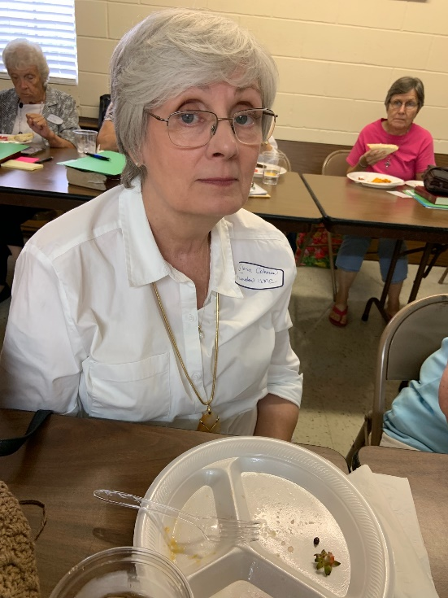 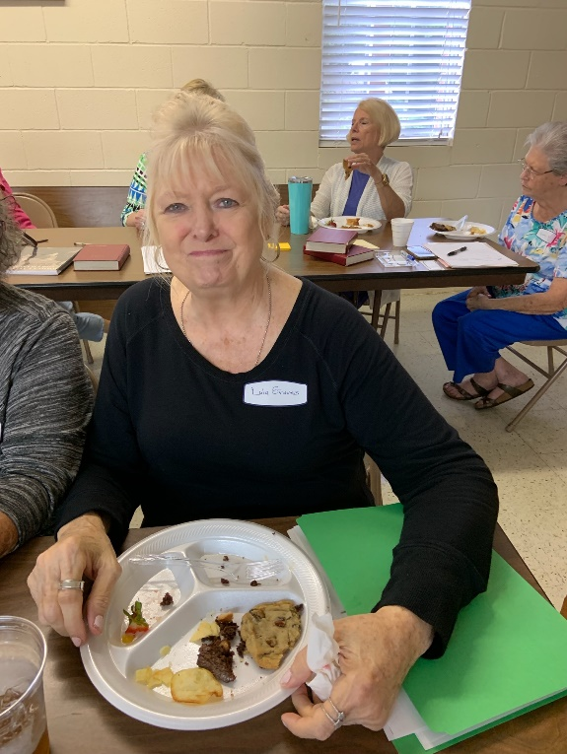 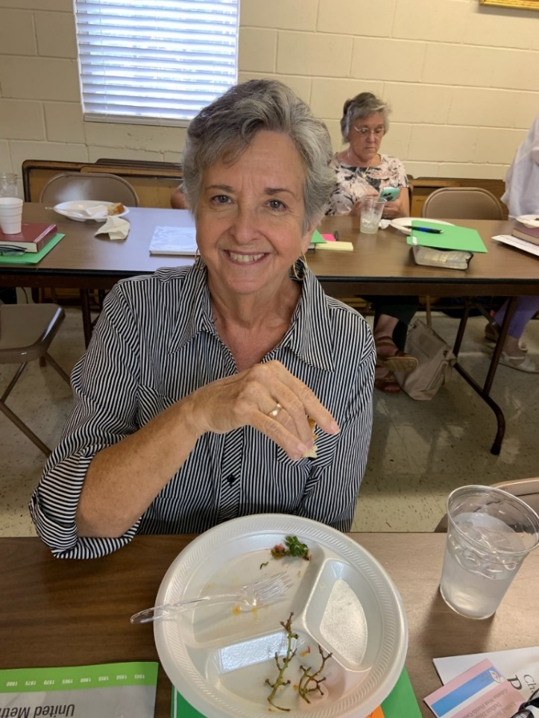

Debbie Bell, President

Alabama-West Florida United Methodist Women

Alabama West Florida UMW, Southeast Jurisdictional Meeting 2020 to be held in Mobile

**ONLINE REGISTRATION**: Website:  [http://wwwsej.org](http://wwwsej.org/)

**LOCATION OF SEJ EVENT**:  Renaissance Riverview Plaza Hotel - 64 South Water Street, Mobile, Alabama  Phone: direct to the hotel:251-438-4000  or the 800 number: 1-800-922-3298

A block of rooms has been reserved until March 15, 2020.

COST OF ROOMS:  $129 plus tax per room Friday through Saturday night.  When making reservations to receive this special rate you must mention **Southeastern Jurisdiction United Methodist Women.**

**REGISTRATION:**Early Bird Registration cost is: $185 per person - deadline for early bird registration is December 1, 2019.  After Dec. 1, 2019 will be: $210.  After March 2 there is a late fee of $25 for a total of $235. Registration closes March 15, 2020.

Registration refund: 50% up to March 15, 2020.  NO REFUNDS after March 15, 2019

**CHECK-IN**:  8 a.m.  - 5:30 p.m. in the lobby of the hotel on Friday, April 17, 2020. Persons arriving after 6:00 p.m. on Friday should make prior arrangements with Registrar, Gertrude Stewart.  Registration will continue on Saturday from 7:00 a.m. until 8:00 a.m.

**MISSION EVENT**: Ubuntu Day will be a workday at Dumas Wesley Community Center. Departing from the hotel at 9:30 a.m. on Friday - returning to the hotel about 2:30.   There is a $35 fee to be paid during Online Registration.   If your conference would like to donate items to this United Methodist Women supported facility I have listed a few items as suggestions for the Sybil Smith Apartments (there are 17 apartments for single parents with children to live for up to 2 years while they are learning parenting skills, work skills, money management skills, etc.)

CRITICAL NEEDS:  dish sets, flatware sets, pots/pans sets, garbage can (kitchen) knife sets, twin comforters, pillows, bath mats, towels, washcloths, hand towels shower curtains, toilet paper, trash bags, storage/organizer for clothes.

NON-CRITICAL NEEDS: aluminum foil, zip-lock bags, coffee filters, paper towels, pot holders, measuring spoons, measuring cups, kid’s sippy cups, can opener, coffee pot, pitcher, mops/brooms and trash bags to name a few.

**WORKSHOPS:**  We will be offering 10 different workshops with great leaders!  Check them out at our registration site.

**SOUTHEASTERN JURISDICTION LEGACY COOKBOOK:**  The cookbook will be available for purchase at registration. This cookbook will have approximately 20-25 recipes from each conference (LADIES I REALLY NEED YOUR RECIPES NO LATER THAN DEC. 15TH.)  and it will also include a brief history of each conference (LADIES ALSO NEED THAT INFO BY THE DEC.15TH DEADLINE AS WELL.  I HAVE INFO ON EACH CONFERNCE FROM 1940-1964).

Cost at registration will be $15 - at the event: $20.  All proceeds will go to the Legacy Fund Campaign.

**MEALS:**Meals included area box lunch and the dinner banquet on Saturday.  You are responsible for any other meals. The hotel will have several Kiosk stations in the hotel as well as the restaurant located in the hotel.  There are several restaurants in the close vicinity of the hotel.

**PARKING**: The hotel has a parking garage.  We have a special rate of $8 per day (you must mention the SEJUMW event.  You cannot go in or out without paying each time.  For Charter buses, there is parking space available in the adjoining convention center as a cost of $25 per day.

**TRAVEL:** At Online Registration, your mode of travel, your arrival and departure times must be included.  Airport shuttle to and from the airport is complimentary. You must notify the Registrar, Gertrude Stewart if you will be using the shuttle.

**ONSITE CHILDCARE**:  Childcare for ages 2 years to 10 years will be available during the times we are in session at a cost of $50 per child.  Snacks and juice include. No meals.

**LOCAL SITES/THINGS TO DO**: The Mobile area has numerous world-class attractions including The USS ALABAMA Battleship Memorial Park, Bellingrath Gardens and Home, and the Gulf Coast Exploreum Science Center.  Carnival Fantasy offers year-round voyages from Mobile to exotic ports in the Western Caribbean to include Cozumel, Progresso, and Costa Maya.  In addition to sight-seeing opportunities, Mobile has numerous locally owned popular restaurants featuring freshly caught gulf seafood that are nearby and convenient to the hotel.  Go to: [meetinmobile.org](http://meetinmobile.org/) for more information about local attractions.

**THE MOBILE REGIONAL AIRPORT:** is served by Delta Airlines, US Airways, American and United Airlines that offer daily non-stops from Atlanta, Charlotte, Dallas, Houston, and Chicago.  There are 40+ daily flights.

**PURPOSE**

United Methodist Women shall be a community of women whose purpose is

to know God and to experience freedom as whole persons through Jesus Christ;

to develop a creative, supportive fellowship; and to expand concepts of mission

through participation in the global ministries of the church.

**Vision:**

Turning Faith Hope and Love into Action on behalf of women, children and youth.

**Theme:**

Love in Action

1 John 3:18, “Let us not love with words or speech but with actions and in truth.”

.